**UNIT 2**

**Wireless Sensors Network**

A Wireless Sensor Network (WSN) is a network of interconnected sensor nodes that communicate with each other wirelessly to collectively gather and transmit data from their surrounding environment. These sensor nodes are equipped with various types of sensors, processing capabilities, and wireless communication modules, allowing them to monitor, collect, and transmit data from different points in a physical space.

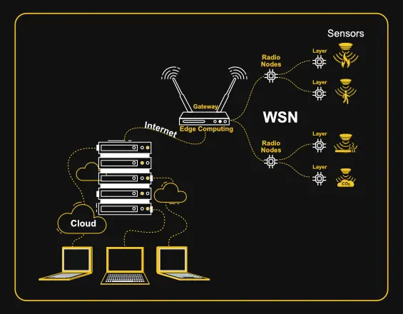

**Components of WSN**

* **Sensors:** Sensors in WSN are used to capture the environmental variables and which is used for data acquisition. Sensor signals are converted into electrical signals.
* **Radio Nodes:** It is used to receive the data produced by the Sensors and sends it to the WLAN access point. It consists of a [microcontroller](https://www.geeksforgeeks.org/microcontroller-and-its-types/), transceiver, external memory, and power source.
* **WLAN Access Point:** It receives the data which is sent by the Radio nodes wirelessly, generally through the internet.
* **Evaluation Software:** The data received by the WLAN Access Point is processed by a software called as Evaluation Software for presenting the report to the users for further processing of the data which can be used for processing, analysis, storage, and mining of the data.

**Advantages**

* **Low cost:**WSNs consist of small, low-cost sensors that are easy to deploy, making them a cost-effective solution for many applications.
* **Wireless communication:** WSNs eliminate the need for wired connections, which can be costly and difficult to install. Wireless communication also enables flexible deployment and reconfiguration of the network.
* **Energy efficiency:**WSNs use low-power devices and protocols to conserve energy, enabling long-term operation without the need for frequent battery replacements.
* **Scalability:**WSNs can be scaled up or down easily by adding or removing sensors, making them suitable for a range of applications and environments.
* **Real-time monitoring:**WSNs enable real-time monitoring of physical phenomena in the environment, providing timely information for decision making and control.

**Disadvantages**

* **Limited range:**The range of wireless communication in WSNs is limited, which can be a challenge for large-scale deployments or in environments with obstacles that obstruct [radio signals.](https://www.geeksforgeeks.org/radio-waves/)
* **Limited processing power:** WSNs use low-power devices, which may have limited processing power and memory, making it difficult to perform complex computations or support advanced applications.
* **Data security:**WSNs are vulnerable to security threats, such as eavesdropping, tampering, and denial of service attacks, which can compromise the confidentiality, integrity, and availability of data.
* **Interference:** Wireless communication in WSNs can be susceptible to interference from other wireless devices or radio signals, which can degrade the quality of data transmission.
* **Deployment challenges:**Deploying WSNs can be challenging due to the need for proper sensor placement, power management, and network configuration, which can require significant time and resources.

**Participatory Sensing**

Participatory Sensing is an approach to data collection and interpretation in which individuals, acting alone or in groups, use their personal mobile devices and web services to explore interesting aspects of their worlds systematically—ranging from health to culture.

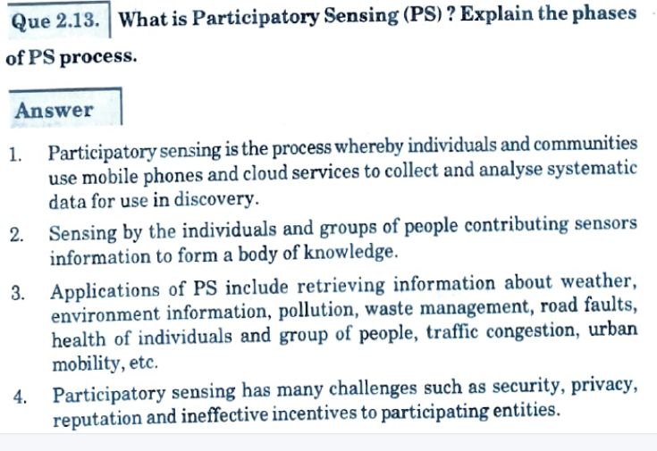

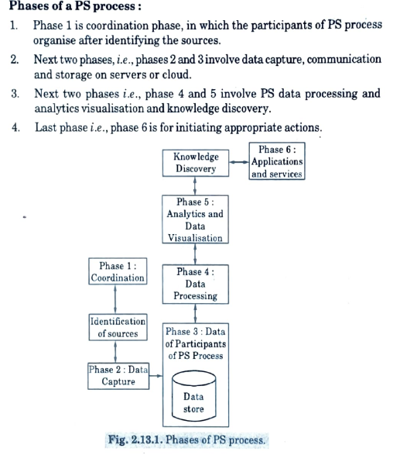

**Six Phases PS process**

• Phase 1 coordination, in which the participants of PS process organise after identifying the sources

• Phase 2 and 3 data capture, communication and storage on servers or cloud.

• Phases 4 and 5—PS data processing and analytics, visualization and knowledge discovery.

• Phase 6 is for initiating appropriate actions.

1. During the Coordination phase the participants need to either organize themselves, or be recruited by some other entity (e.g. city authorities) within the context of a sensing campaign, and the objective of the campaign needs to be communicated among all of them.
2. Then the participants spend some predetermined amount of time to capture (Capture phase) the desired sensing modalities using their mobile phone applications or custom designed applications for the sensing campaign.
3. The collected data are transferred (Transfer & Storage phase) to the data collection system through the phone connectivity options and stored in Internet servers (private or public). The data are then subject to pre- processing (Process phase) so that the privacy of the data collectors is preserved, and access control rules are added so that the data can be accessed anytime by only authorized individuals or services.
4. The collected data are analyzed by relevant analysis tools, aggregated(if possible), correlated with each other in order to detect patterns, and in the end visualized for better understanding for the target group of the campaign (Analysis and Visualization phase).
5. Last but not least, certain actions (Action phase) may be taken by individuals or city authorities

**Applications of PS**

* Retrieving information individual and group of people
* Weather, environment information, pollution
* Information for waste management, road faults
* Health, traffic congestion and urban mobility

**Embedded Devices (System) in (IoT)**

It is essential to know about the embedded devices while learning the IoT or building the projects on IoT. The embedded devices are the objects that build the unique computing system. These systems may or may not connect to the Internet.

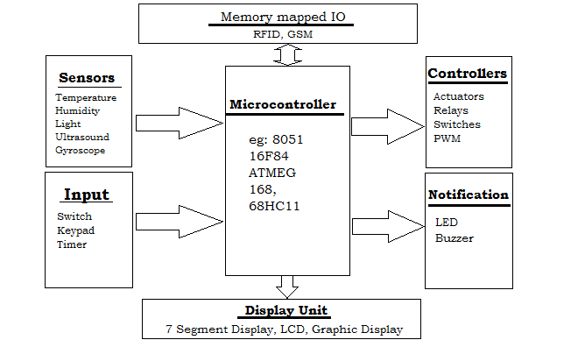

**Components of Embedded Systems**

**1.** Hardware **2.** Software **3.** Firmware

**Examples of Embedded Systems**

* Digital watches
* Washing Machine
* Toys
* Televisions
* Digital phones
* Laser Printer
* Cameras
* Industrial machines
* Electronic Calculators
* Automobiles
* Medical Equipment

**Application of Embedded System**

* Home appliances
* Transportation
* Health care
* Business sector & offices
* Defense sector
* Aerospace
* Agricultural Sector

**Characteristics of an Embedded System**

* **Performs specific task:** Embedded systems perform some specific function or tasks.
* **Low Cost:**The price of an embedded system is not so expensive.
* **Time Specific:** It performs the tasks within a certain time frame.
* **Low Power:** Embedded Systems don’t require much power to operate.
* **High Efficiency:** The efficiency level of embedded systems is so high.
* **Minimal User interface:**These systems require less user interface and are easy to use.
* **Less Human intervention:** Embedded systems require no human intervention or very less human intervention.
* **Highly Stable:** Embedded systems do not change frequently mostly fixed maintaining stability.
* **High Reliability:** Embedded systems are reliable they perform tasks consistently well.
* **Use microprocessors or microcontrollers:** Embedded systems use [microprocessors](https://www.geeksforgeeks.org/introduction-of-microprocessor/) or [microcontrollers](https://www.geeksforgeeks.org/microcontroller-and-its-types/) to design and use limited memory.
* **Manufacturable:**The majority of embedded systems are compact and affordable to manufacture. They are based on the size and low complexity of the hardware.

**Advantages of Embedded System**

* Small size.
* Enhanced real-time performance.
* Easily customizable for a specific application.

**Disadvantages of Embedded System**

* High development cost.
* Time-consuming design process.
* As it is application-specific less market available.

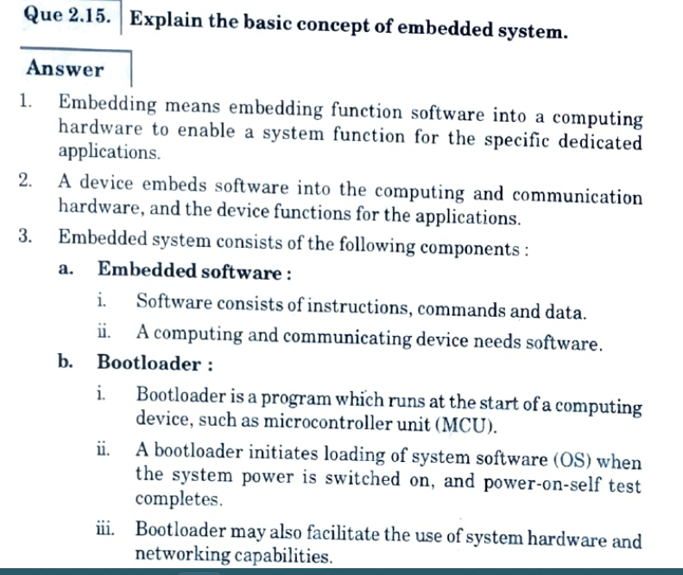

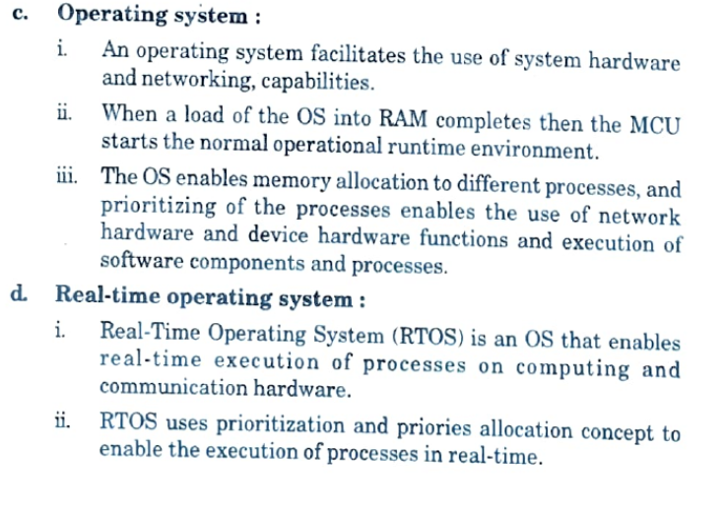

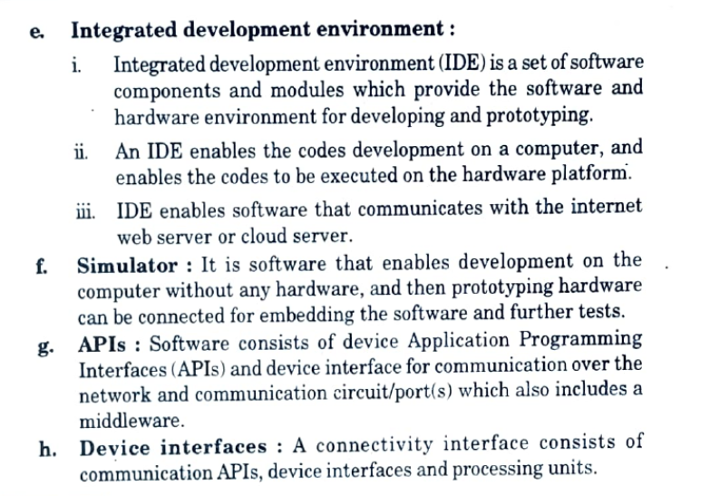

**Overview of IoT hardware platforms (Arduino, Raspberry Pi, etc.)**

**Arduino:**

Arduino is an open-source electronics platform that is easy to use and is designed for beginners. It is based on a microcontroller and provides an environment for building and programming projects in a simple and intuitive way. The Arduino platform is widely used for building IoT projects because it is low-cost and has a vast community of developers. Arduino boards can be programmed using the Arduino IDE (Integrated Development Environment) which is available for Windows, Mac, and Linux.

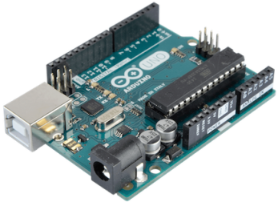

There are many different types of Arduino boards available, but they all share the same basic features. They have digital and analog inputs and outputs, which allow them to interact with a wide range of sensors and actuators. They also have built-in communication protocols such as USB, UART, SPI, and I2C, which allow them to communicate with other devices.

**Raspberry Pi:**

Raspberry Pi is a low-cost, credit-card-sized computer that was designed for education and experimentation. It is based on an ARM processor and is capable of running a full-fledged operating system. Raspberry Pi boards are more powerful than Arduino boards and have more RAM and processing power. This makes them suitable for more complex IoT projects.

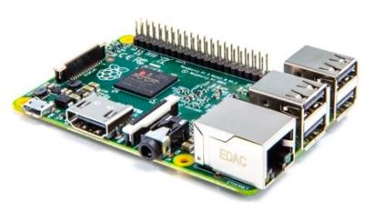

Like Arduino, Raspberry Pi has a large community of developers and enthusiasts, which makes it a popular choice for building IoT projects. Raspberry Pi boards can run a variety of operating systems including Raspbian, Ubuntu, and Windows 10 IoT Core. They can also be programmed using a variety of programming languages including Python, JavaScript, and C/C++.

Compared to Arduino, Raspberry Pi has more built-in connectivity options such as Ethernet, Wi-Fi, and Bluetooth. It also has a built-in HDMI output, which makes it easy to connect to a monitor or TV. These features make Raspberry Pi a popular choice for building IoT projects that require more connectivity options and graphics capabilities.

**Which one to choose?**

The choice between Arduino and Raspberry Pi depends on the specific requirements of your IoT project. If you are building a simple project that only requires basic sensing and actuation, then Arduino is a good choice. It is easy to use and is designed for beginners. On the other hand, if you are building a more complex project that requires more processing power and connectivity options, then Raspberry Pi is a better choice.



